ORTHOPAEDIC INSTRUMENTS
Basic Instruments for Mini Bone Plating
Bone Elevators – Hohmann Type
Intended Use
Hohmann-type bone elevators are essential veterinary orthopaedic instruments used to retract soft tissue, periosteum and muscles away from bone surfaces during mini bone plating procedures. They are widely used in fracture fixation of small bones in dogs and cats, providing clear surgical access to mini plate application sites. | 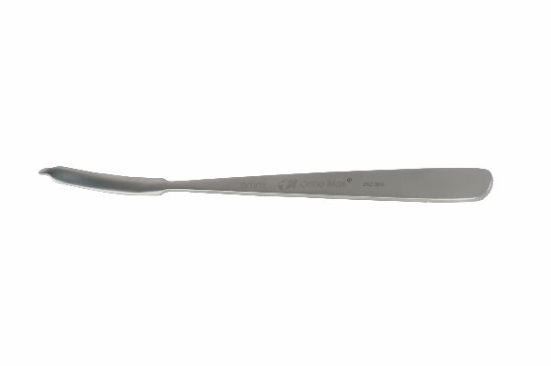
Function
The instrument features a curved, spatula-shaped blade attached to a contoured handle. The blade tip is introduced subperiosteally and levered against the bone cortex, displacing surrounding soft tissue to create an unobstructed operative field. Available in varied blade widths for different bone sizes.
Advantages
Atraumatic Soft Tissue Protection: The smooth, rounded blade profile slides cleanly along the periosteum without lacerating vessels or nerves, preserving the biological environment critical for fracture healing in small animal orthopaedics.
Versatile Bone Access: Multiple blade widths accommodate mini plating on the radius, ulna, tibia and metatarsal bones of small breeds, making this a go-to retractor across diverse paediatric and toy-breed fracture cases.
FAQ
Q: What bones are Hohmann elevators used on in mini bone plating?
A: They are routinely used on the radius, ulna, tibia, femur and metacarpals of small dogs and cats during mini plate application for fracture stabilisation.
Q: How do I prevent bone damage when using a Hohmann elevator?
A: Keep the blade subperiosteal, apply steady controlled lever pressure rather than sudden force, and select the correct blade width to match the bone circumference.

ORTHOPAEDIC INSTRUMENTS
Basic Instruments for Mini Bone Plating
Bone Tap
Intended Use
The bone tap is a precision threading instrument used in mini bone plating surgery to cut internal threads inside pre-drilled pilot holes in cortical bone. It ensures accurate screw engagement during fracture fixation in small animals, maximising pull-out resistance of mini cortical screws. | 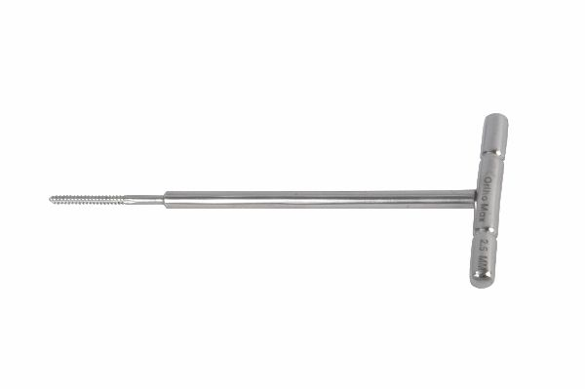
Function
The tap carries helical flutes with hardened cutting edges that match the thread pitch of the implant screws. When rotated clockwise into the drilled hole, the flutes shave cortical bone into a clean internal thread. A T-handle provides the torque needed while allowing tactile feedback to prevent stripping.
Advantages
Precise Thread Formation: Correct tapping creates threads that perfectly match the mini screw profile, maximising bone-screw interface strength and preventing implant micromotion that could compromise fracture healing.
Reduced Screw Insertion Torque: Pre-tapping decreases resistance during screw driving, lowering the risk of cortical crack propagation — especially important in the thin cortices of toy-breed dogs and feline long bones.
FAQ
Q: Is tapping always necessary in mini bone plating?
A: Self-tapping screws can be used in soft cancellous bone, but tapping is recommended in hard cortical bone of active or large small-breed dogs to ensure full thread engagement.
Q: How do I avoid breaking a tap inside bone?
A: Use sharp taps, apply steady rotational pressure without side-loading, and back off a quarter turn periodically to clear bone chips from the flutes.

ORTHOPAEDIC INSTRUMENTS
Basic Instruments for Mini Bone Plating
Depth Gauge
Intended Use
The depth gauge is a measurement instrument used in mini bone plating to determine the exact depth of a drilled pilot hole before screw selection. Accurate measurement ensures the correct mini screw length is chosen, preventing cortex penetration and optimising bicortical fixation in small animal fracture repair. | 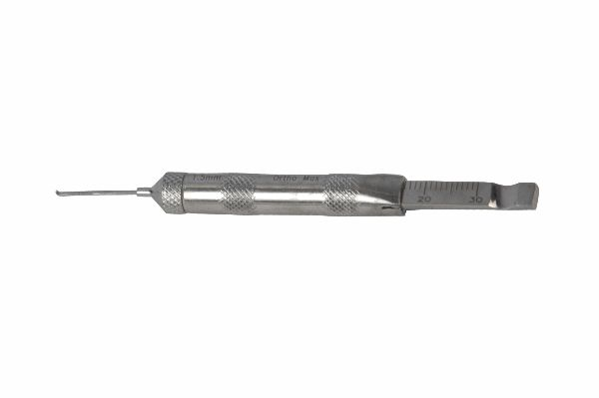
Function
A hooked tip is inserted into the drilled hole and advanced until it catches the far cortex. A calibrated sliding scale on the shaft is then read at the near cortex level to give the bone thickness measurement directly in millimetres, guiding selection of the appropriate screw length from the implant set.
Advantages
Prevents Incorrect Screw Length: Selecting a screw that is too long risks penetrating far-cortex soft tissue and neurovascular structures; too short a screw provides inadequate pull-out strength. The gauge eliminates guesswork and reduces intraoperative complications.
Speeds Operative Workflow: Instant, on-table measurement avoids repeated radiographic checks for screw length, shortening anaesthesia time and improving throughput in busy small animal orthopaedic practices.
FAQ
Q: Can the depth gauge be used for both cortical and locking mini screws?
A: Yes. The gauge measures the bone channel depth regardless of screw type; the surgeon then selects from the appropriate cortical or locking screw lengths in the mini plating set.
Q: What is the measurement range of a mini bone plating depth gauge?
A: Most mini depth gauges measure from 6 mm to 26 mm, covering the thin cortical bones of small dogs and cats encountered in mini plating cases.

ORTHOPAEDIC INSTRUMENTS
Basic Instruments for Mini Bone Plating
Mini Bone Drill
Intended Use
The mini bone drill is a compact hand-powered drilling instrument used to create precise pilot holes in small animal cortical bone during mini bone plating procedures. It provides controlled, low-heat drilling essential for maintaining bone viability around fracture fixation implants in dogs and cats. | 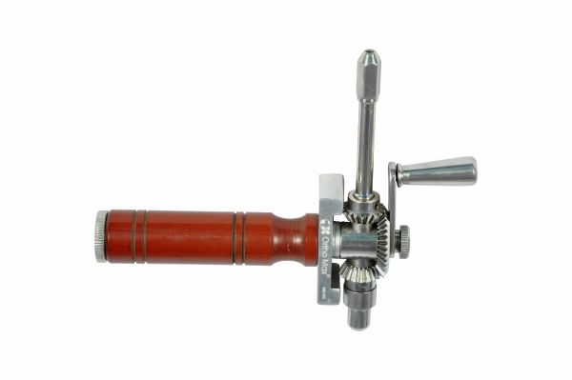
Function
The instrument uses a pinion-and-chuck mechanism driven by a T-bar handle. Stainless steel drill bits are clamped in the chuck and rotated at controlled speed by hand, producing clean, accurately sized holes through cortical bone without the thermal damage associated with high-speed power drills.
Advantages
Thermal Damage Prevention: Hand-driven speed generates far less frictional heat than powered drills, protecting the periosteum and endosteum from thermal necrosis — a key factor in preserving the local bone stock needed for secure mini screw purchase.
Precise Directional Control: Manual operation gives the surgeon direct tactile feedback on drill-bit breakthrough, preventing plunge injury to underlying nerves, vessels and soft tissue structures adjacent to small animal long bones.
FAQ
Q: What drill bit sizes are used with mini bone drills?
A: Mini plating systems typically use 1.5 mm, 2.0 mm, and 2.5 mm drill bits matched to the screw core diameters in the instrument set.
Q: Can the mini bone drill be autoclaved?
A: Yes. All components are manufactured from surgical-grade stainless steel and are fully autoclavable at standard 134 °C pre-vacuum sterilisation cycles.

ORTHOPAEDIC INSTRUMENTS
Basic Instruments for Mini Bone Plating
Modelling Lever
Intended Use
The modelling lever is a contouring instrument used during mini bone plating to fine-adjust the shape of a pre-bent plate so it conforms precisely to the bone surface. Accurate plate-to-bone contact is essential for stable fixation and optimal load sharing in small animal fracture repair. | 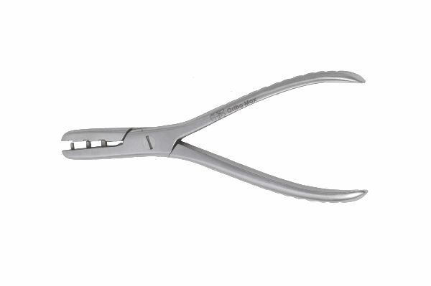
Function
The lever's notched or slotted working end engages the plate edge or hole margins. By applying controlled bending force through the ergonomic handle, the surgeon induces small incremental deformations in the plate, achieving a custom contour that matches individual patient bone anatomy without stress-risers.
Advantages
Patient-Specific Plate Contouring: Every bone has unique curvature; the modelling lever allows the surgeon to match plate contour exactly, eliminating plate-bone gaps that generate toggling forces on screws and lead to implant failure.
Minimises Plate Fatigue Risk: Incremental, controlled bending using the lever avoids over-bending or kinking the plate, preserving metal integrity and reducing the risk of intraoperative or postoperative plate fracture.
FAQ
Q: How many times can a mini plate be re-bent with the modelling lever?
A: Most implant manufacturers recommend bending each plate no more than two to three times; repeated bending creates metal fatigue that reduces the plate's cyclic load endurance.
Q: Should plates be contoured before or after sterilisation?
A: Initial contouring can be done pre-sterilisation using a plastic bone model, then fine-adjusted on the sterile field using the modelling lever to achieve exact anatomical fit.

ORTHOPAEDIC INSTRUMENTS
Basic Instruments for Mini Bone Plating
Ordinary Screwdriver with Fibre Handle
Intended Use
This screwdriver is a manual torque delivery instrument used to insert and tighten mini cortical screws during small animal bone plating procedures. The fibre handle provides a non-slip, heat-resistant grip that allows precise torque control when securing mini plates to fractured bones in dogs and cats. | 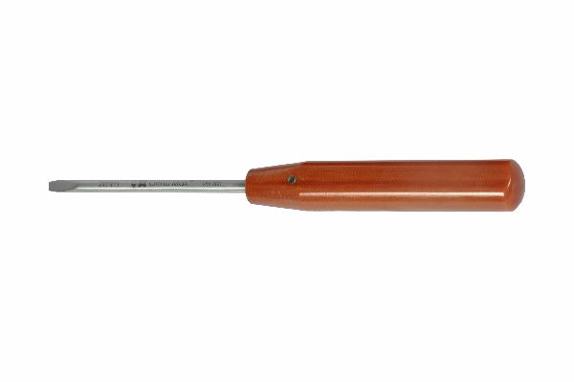
Function
A precisely machined hex or cross-point tip engages the screw head recess. The surgeon applies rotational force through the ergonomic fibre handle while maintaining axial alignment, driving the screw into the tapped cortical hole until the screw head seats flush against the plate without over-torquing the bone-screw interface.
Advantages
Tactile Torque Feedback: The rigid fibre handle transmits fine vibrations from the screw-bone interface directly to the surgeon's hand, signalling full engagement or impending strip-out — preventing costly implant failures during mini plate fixation.
Non-Magnetic Compatibility: Fibre handles contain no ferromagnetic components, making this screwdriver compatible with intraoperative C-arm fluoroscopy and MRI-compatible theatre environments in advanced small animal surgical facilities.
FAQ
Q: What torque should be applied when inserting mini cortical screws?
A: Most mini screw systems specify 0.3–0.6 Nm depending on screw diameter; use a torque-limiting driver when exact values are critical, especially in osteopenic bone.
Q: How do I prevent screw head cam-out with this screwdriver?
A: Maintain strict axial alignment between the driver tip and screw head recess, and ensure the tip size matches the screw head exactly to prevent cam-out and screw head damage.

ORTHOPAEDIC INSTRUMENTS
Basic Instruments for Mini Bone Plating
Plate Bender for Reconstruction Plates
Intended Use
The plate bender for reconstruction plates is a contouring instrument designed to shape stainless steel or titanium mini reconstruction plates to match complex bone surfaces. It is used in veterinary orthopaedic fracture repair where standard straight plates cannot conform to curved or irregularly shaped bone segments. | 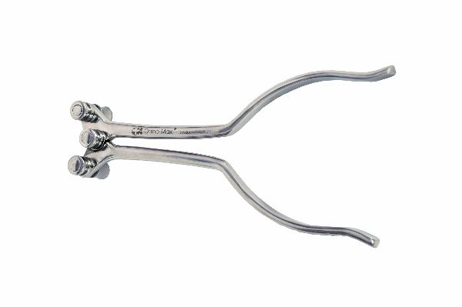
Function
Two offset rollers or notched bending jaws grip the plate at two defined points. When the handles are squeezed, a controlled bending moment is applied across the plate segment between the jaws, producing a smooth, even curve. Repositioning the instrument allows stepwise contouring along the full plate length.
Advantages
Complex 3-D Contouring: Reconstruction plates have transverse cuts between holes that permit multi-planar bending; this dedicated bender exploits those cuts to achieve accurate medial, lateral, and torsional contours for complex juxta-articular fractures.
Implant Integrity Preservation: The wide jaw span distributes bending stress evenly, preventing notching or kinking at hole margins that would create stress-riser fracture points in the plate during load bearing.
FAQ
Q: Can this bender be used on locking reconstruction plates?
A: Yes, but locking plate contouring should be minimal; excessive bending changes hole geometry and prevents locking screw thread engagement, compromising the angle-stable construct.
Q: What plate thickness ranges does this bender accommodate?
A: Mini reconstruction plate benders typically handle plate thicknesses from 1.0 mm to 2.5 mm, covering the range used in small and medium-breed veterinary orthopaedics.

ORTHOPAEDIC INSTRUMENTS
Basic Instruments for Mini Bone Plating
Plate Bending Forceps – Modified
Intended Use
Modified plate bending forceps are precision hand instruments used in mini bone plating to make fine, localised bends in small orthopaedic plates. They allow veterinary surgeons to adjust plate contour directly on the operative field to achieve intimate plate-to-bone contact during fracture fixation. | 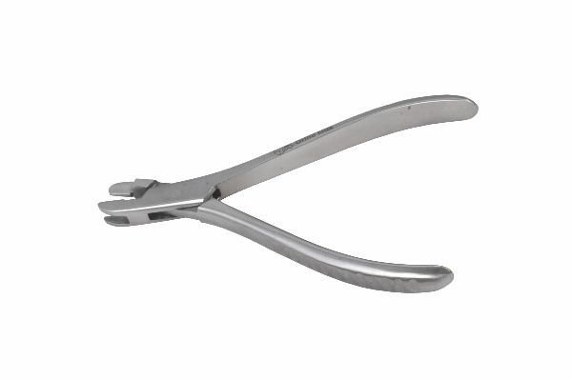
Function
The modified forceps feature offset jaws with smooth gripping faces that clamp onto the plate without leaving surface marks. Squeezing the ratchet-locked handles applies a concentrated bending moment between the two jaw contact points, allowing millimetre-precise angulation corrections at individual plate holes.
Advantages
On-Table Fine Adjustments: Unlike roller-type benders, the forceps can make precise in-situ corrections while the plate is being trialled on the bone, dramatically reducing the number of plate removal-and-rebend cycles needed.
Surface-Mark-Free Gripping: Smooth jaw faces grip without gouging, preserving the plate's corrosion-resistant surface finish and preventing initiation of crevice corrosion sites that could compromise long-term implant performance.
FAQ
Q: How are plate bending forceps different from a plate bender?
A: Plate bending forceps make small localised corrections at specific locations, while a roller-type plate bender produces sweeping uniform curves along the plate length — both are often used together.
Q: Can the modified forceps be used to straighten an over-bent plate?
A: Yes, but reverse bending should be limited to one correction; each additional bend cycle reduces the plate's fatigue life and increases fracture risk under cyclic loading.

ORTHOPAEDIC INSTRUMENTS
Basic Instruments for Mini Bone Plating
Plate Holding Fork
Intended Use
The plate holding fork is a retaining instrument used to maintain mini bone plates in accurate position against the fracture site while the first screw is inserted. It is a critical time-saving instrument in small animal bone plating that prevents plate migration during initial fixation. | 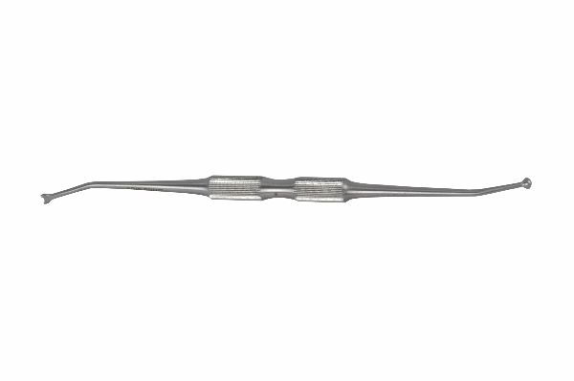
Function
Two prongs straddle a plate hole and grip the surrounding plate web. The ergonomic handle allows the assistant or surgeon's non-dominant hand to stabilise the plate while the dominant hand drives the first screw, ensuring the plate remains perfectly aligned to the bone axis before final fixation.
Advantages
Maintains Plate Alignment: Even slight plate movement during first-screw insertion misaligns subsequent holes, forcing screw obliquity that reduces pull-out strength. The fork locks the plate in position, delivering a mechanically sound construct.
Single-Surgeon Application: The fork's grip is stable enough for a single surgeon to hold the plate, drill, and insert the first screw without assistance — a practical advantage in low-staffing emergency orthopaedic settings.
FAQ
Q: Which plate holes does the fork grip?
A: The fork is placed over an intermediate hole near the fracture line, so the surgeon can insert the first screw in the hole closest to the fracture for optimal reduction maintenance.
Q: Is a plate holding fork needed for every mini plating case?
A: It is strongly recommended for all cases; even short plates can rotate during first-screw insertion, and plate misalignment is far harder to correct once the first screw is in.

ORTHOPAEDIC INSTRUMENTS
Basic Instruments for Mini Bone Plating
Plier
Intended Use
The orthopaedic plier is a multi-purpose gripping and bending instrument used across mini bone plating procedures. It is used to grip wires, bend implants, manipulate small plates and handle other components of the mini plating set during veterinary fracture fixation surgery. | 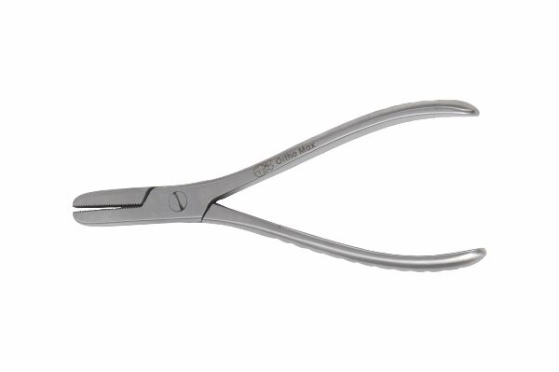
Function
Serrated or smooth-faced jaws provide a secure grip on flat or round implant material. A box-joint hinge delivers high grip force with controlled jaw opening, while the spring-loaded handle offers one-handed operation for rapid implant manipulation during fast-paced surgical sequences.
Advantages
Universal Implant Handling: Suitable for gripping K-wires, bending cerclage wire, handling mini screws and manipulating plates, the plier reduces the number of instruments needed on the sterile field and simplifies instrument tray setup.
Controlled Grip Force: The box-joint construction keeps jaw faces parallel under load, ensuring even grip pressure that avoids scoring implant surfaces — critical for maintaining the passivation layer on stainless steel plates and screws.
FAQ
Q: Can the orthopaedic plier bend K-wires?
A: Yes. The sturdy jaws provide enough leverage to make small angular corrections in 1.0–1.6 mm K-wires during intraoperative wire positioning for supplementary fixation alongside mini plates.
Q: Is there a risk of implant surface damage from plier use?
A: Serrated jaws can mark soft metal surfaces; where surface integrity is critical, smooth-jawed pliers should be used, and jaw marks should be checked post-procedure before implant reuse.

ORTHOPAEDIC INSTRUMENTS
Basic Instruments for Mini Bone Plating
S.S. Drill Bits for Hand Drill
Intended Use
Stainless steel drill bits for hand drills are precision cutting tools used in mini bone plating to create accurate pilot holes in cortical bone prior to screw insertion. Available in diameters matched to mini screw core sizes, they are essential consumables in veterinary small bone fracture fixation. | 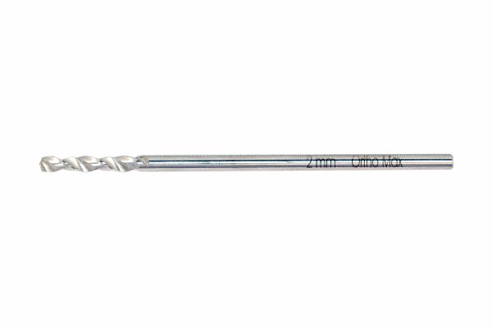
Function
Each bit carries two or three helical flutes with hardened cutting edges that shear bone as the bit rotates. The smooth shank locks into the hand drill chuck, while the flutes carry bone debris proximally away from the cutting tip, maintaining a clear hole and preventing heat build-up in the drilling zone.
Advantages
Precise Hole Diameter Control: Accurately sized holes prevent under-drilling (excess insertion torque causing cortex cracking) or over-drilling (reduced screw purchase), both critical failure modes in the thin cortices of toy-breed fracture patients.
Minimal Thermal Osteonecrosis: The sharp flutes and hand-drill speed generate low frictional heat, protecting the 1–2 mm of viable cortical bone immediately around the hole from thermal damage that would reduce screw purchase strength.
FAQ
Q: How often should drill bits be replaced?
A: Dull bits require higher insertion force and generate more heat. Replace bits after every 5–10 cases or when visual inspection reveals rolled cutting edges or tip deformation.
Q: What diameter bits are included in a mini bone plating set?
A: Standard mini sets include 1.5 mm, 2.0 mm, and 2.5 mm bits corresponding to 2.0 mm, 2.7 mm, and 3.5 mm mini screw sizes commonly used in small animal orthopaedics.

ORTHOPAEDIC INSTRUMENTS
Basic Instruments for Mini Bone Plating
Screws & Plate Holding Forceps
Intended Use
Screws and plate holding forceps are dual-purpose gripping instruments used to position and hold mini plates and individual screws during veterinary bone plating procedures. They provide precise control when introducing small implants into the sterile field without direct finger contact that could contaminate the implant surface. | 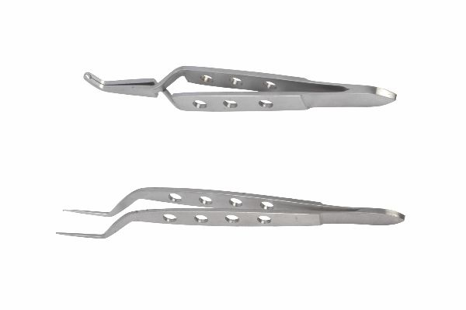
Function
The delicate, narrow-nosed jaws clamp the screw shaft or plate edge through spring-loaded ratchet tension. The surgeon can load a screw onto the driver tip without removing gloves and transfer plates from the implant container to the bone surface with single-hand stability.
Advantages
No-Touch Implant Transfer: Holding forceps maintain strict aseptic technique by eliminating bare-hand contact with screw threads and plate surfaces, reducing implant contamination risk and protecting the oxide passivation layer critical for corrosion resistance.
Prevents Dropped-Implant Events: Secure ratchet locking prevents screws from slipping from the forceps into the wound or off the table — dropped implants must be discarded and replacement costs are significant, especially for titanium mini implants.
FAQ
Q: Can holding forceps grip locking screws without damaging the threads?
A: Yes, provided the jaws clamp the smooth shaft rather than the threaded section; clamping on threads can burr the locking thread profile and prevent proper engagement in the locking plate hole.
Q: Are separate forceps needed for plates and screws?
A: A single pair with appropriately sized jaws handles both tasks, but some surgeons prefer dedicated narrow-nosed screw forceps for precise single-screw placement in confined anatomy.

ORTHOPAEDIC INSTRUMENTS
Basic Instruments for Mini Bone Plating
Self-Holding Screwdriver with Fibre Handle
Intended Use
The self-holding screwdriver is an instrument that retains the mini screw on its tip without additional support, freeing the surgeon's non-dominant hand during bone plating. It is invaluable in veterinary orthopaedics for inserting screws into deep or confined fracture sites in small animals. | 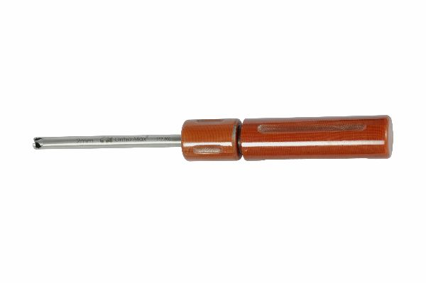
Function
A friction-fit sleeve or spring-loaded pin mechanism grips the screw head recess, holding the screw securely on the driver tip even when inverted. The fibre handle insulates against heat and provides a firm, non-slip grip during the controlled rotational force needed to advance mini cortical screws.
Advantages
One-Handed Screw Insertion: The self-retaining mechanism eliminates the need for forceps to hold the screw, allowing the surgeon to guide and drive simultaneously — particularly valuable in narrow access corridors during minimally invasive plating of small animal long bones.
Reduces Screw Drop Incidence: Retained screws cannot fall into the wound, shortening operative time by eliminating retrieval steps and reducing the rare but serious risk of a retained implant if a dropped screw is overlooked.
FAQ
Q: Does the self-holding mechanism work with all mini screw head types?
A: The mechanism is head-specific; hex-socket and cruciate self-holding drivers are available — ensure the driver matches the implant system's screw head geometry exactly.
Q: When should a self-holding driver be preferred over an ordinary driver?
A: Always in deep wounds, single-surgeon scenarios, or when placing the first screw without an assistant to hold both the plate and screw simultaneously.

ORTHOPAEDIC INSTRUMENTS
Basic Instruments for Mini Bone Plating
Trocar Sleeve – Drill Guide
Intended Use
The trocar sleeve drill guide is a protective instrument used during mini bone plating to guide the drill bit precisely through plate holes into bone while protecting surrounding soft tissue from drill-bit laceration. It ensures perpendicular hole orientation critical for full screw-thread engagement. | 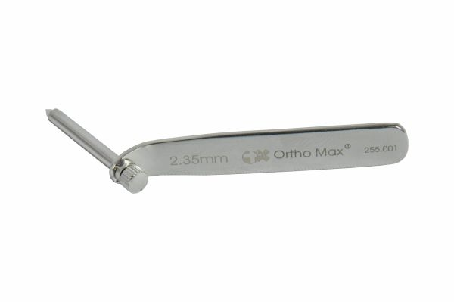
Function
The outer sleeve passes through the plate hole and seats on the bone cortex. The inner trocar is removed once the sleeve is positioned, and the drill bit then passes through the sleeve lumen. The sleeve lip registers against the plate hole, guaranteeing the drill exits the correct diameter path perpendicular to the plate.
Advantages
Soft Tissue Protection: The sleeve isolates the rotating drill from adjacent periosteum, vessels and nerves, preventing drill-wrap injuries and reducing post-operative soft tissue complications in small animal fracture patients.
Perpendicular Screw Tracks: Guided drilling ensures each hole is perpendicular to the plate, maximising screw head-to-plate seating contact and the compressive force transferred across the fracture line during load bearing.
FAQ
Q: Do drill guide sleeves fit all mini plate hole sizes?
A: Sleeves are diameter-specific; the outer diameter must match the plate hole and the inner bore must match the drill bit. Mixing sizes causes eccentric hole placement and screw misalignment.
Q: How is the trocar sleeve cleaned after use?
A: Remove bone debris from the lumen with a cleaning brush under running water immediately after use, then autoclave. Blocked lumens harbour biofilm and reduce guide accuracy.

